DELIVERABLE 4
CSCE 5430
GROUP 10

Lohith Kumar Velkuri
Vynatheya Reddy Vuppunutula
Kiran Kumar Raju Ganga Raju
Srikanth Reddy Ettem

TABLE OF CONTENTS
- Requirements
  - Registration page
  - Login page
  - Admin module
  - Input validation
  - Password encryption
  - Creating user table and inserting data into database from registration page
- UML Design
  - Class Diagram
  - Sequence Diagram
  - Use case Diagram
- Test Cases
  - Password Encryption
  - Testing Ticket Booking Feature
  - Testing Cost Calculation
- Breakdown of Team Roles and Responsibilities
- User Manual
- Compiling/Running Program and Test Cases
- Peer Review Feedback
- Changes to Requirements and Development Phases

REQUIREMENTS
The following components/features were developed during this phase:
- Registration page
- Login page
- Admin module
- Input validation
- Password encryption
- Creating user table and inserting data into database from registration page

Registration page
In this requirement, new users to the web application would be able to register or set up their accounts. In order to do so, the user would be required to provide his/her email, choose a username and password and provide additional details such as phone number, address, etc.

Login page
This system feature enables the existing users to login to their accounts and access the features of the web application such as browsing events for information and booking tickets for the events. The user would be required to enter his/her username and password. After correctly entering the information in both fields, the user would be directed to the homepage.

Admin module
This system feature would include the admin login and functionalities. The responsibilities and tasks of the admin would be to add events, update events and delete events from the web application.

Input validation
This system feature would ensure that any invalid input entered in the login page would result in displaying an error message in the same page. Likewise, any invalid input provided in the registration page would result in displaying an error message in the same page itself.

Password encryption
This feature is used to ensure the security of the users’ passwords. We used the cryptographic hash function SHA-256 to implement this feature.

Creating user table and inserting data into database from registration page
A major requirement in this phase would be to ensure that the user details are being correctly stored in the database. Additionally, we also need to ensure that any changes to data that the user might perform would be reflected in the database.

2. UML DESIGN

Class Diagram

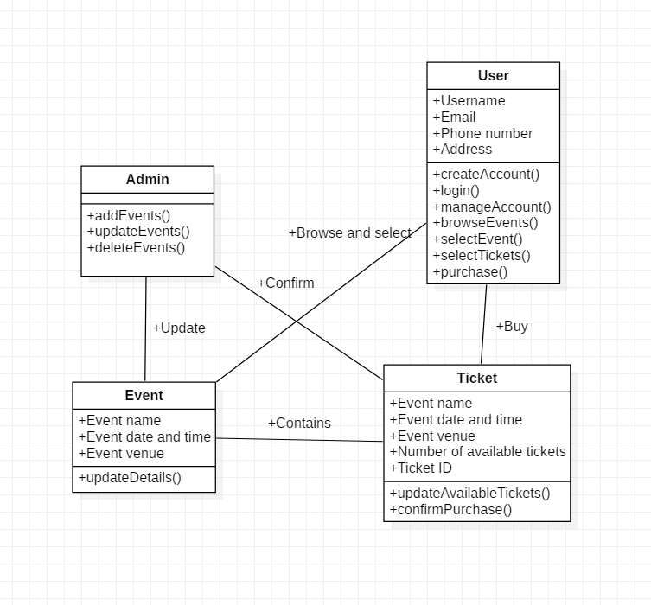Figure 2.1.1. Class Diagram

Sequence Diagram

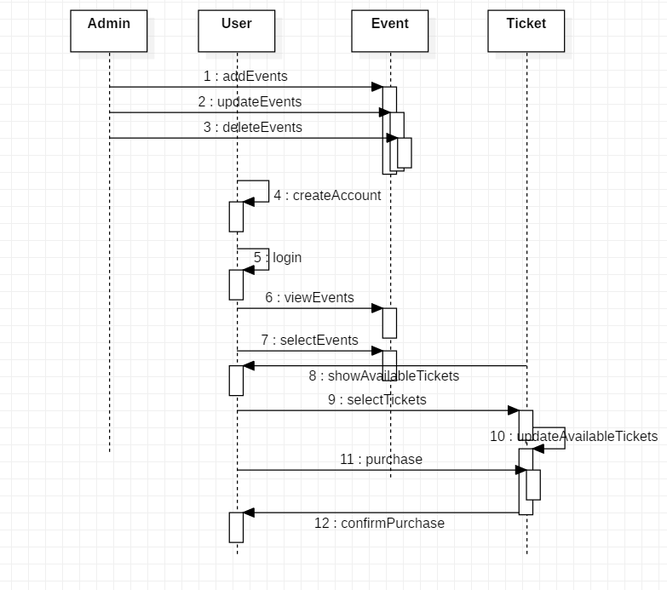Figure 2.2.1. Sequence Diagram

Use Case Diagram
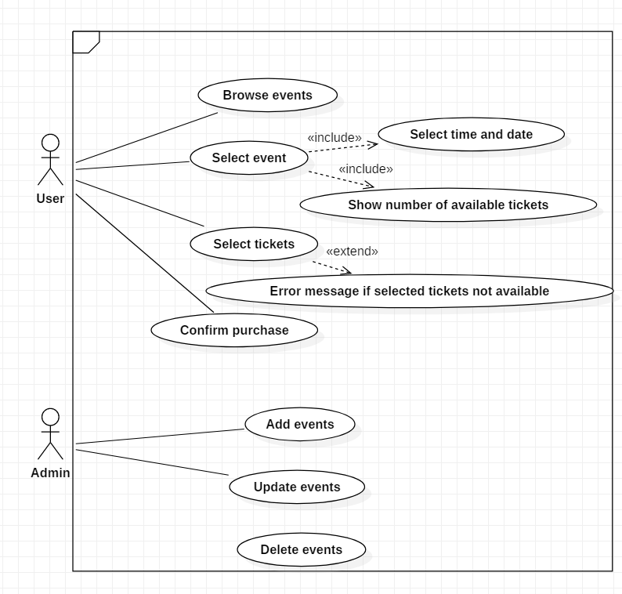
Figure 2.3.1. Use Case diagram

TEST CASES

Password Encryption
Description: This case tests for the correctness in the encryption of passwords. Passwords were encrypted using SHA-256.
Input: Password entered by the user
Output: SHA-256 hashed password
Unit Test Code:
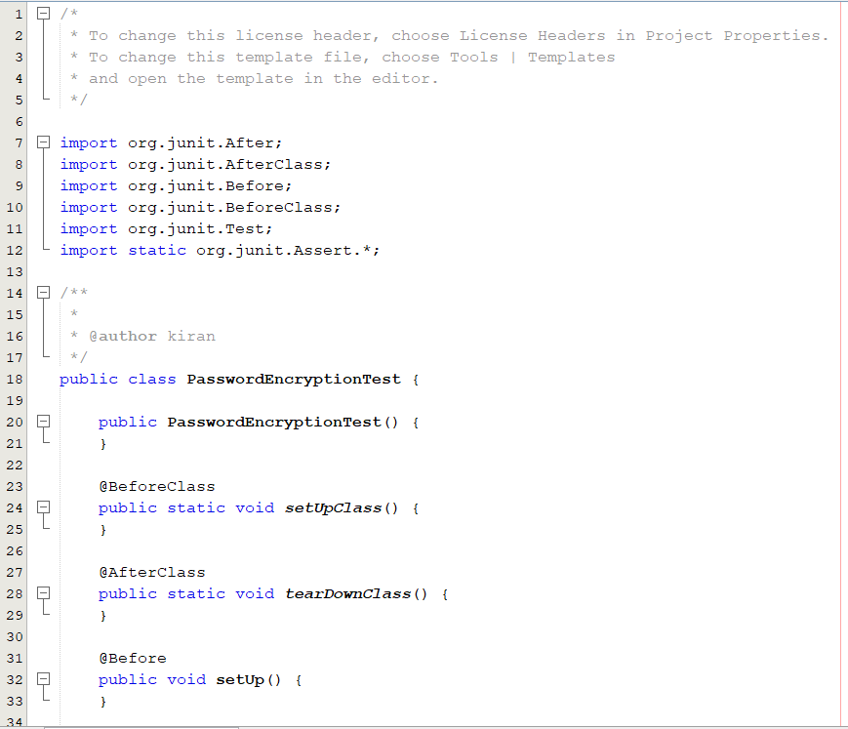
Positive case (Password string and its corresponding hash are entered)
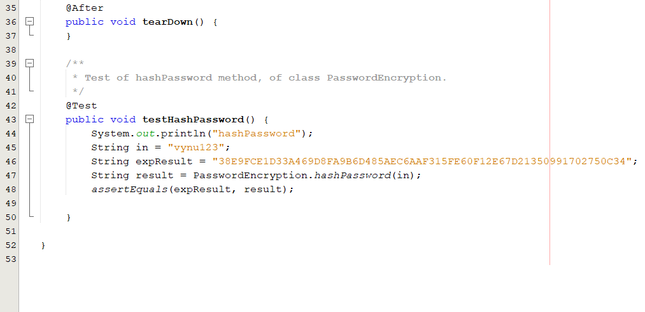
Result
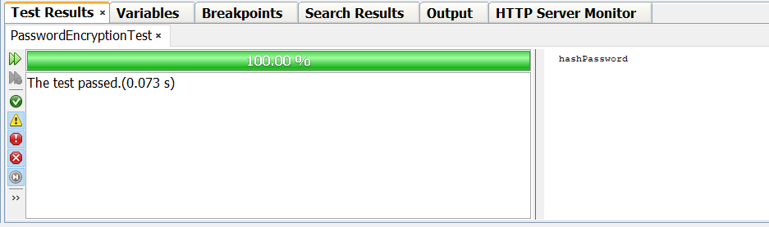
Negative case and result
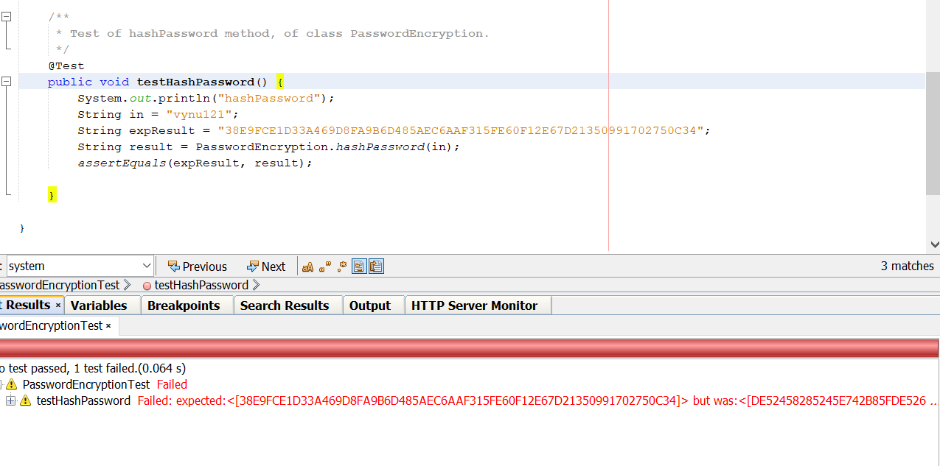

Testing Ticket Booking Feature
Description: This case tests for the correctness in booking the required tickets out of available tickets. This means a user should not be allowed to book more than the available tickets.
Input: The number of tickets the user is requesting to book. ( 1 to 100 – valid input)
Output: True, if the requested tickets is less than available or False, otherwise
Unit Test Code:
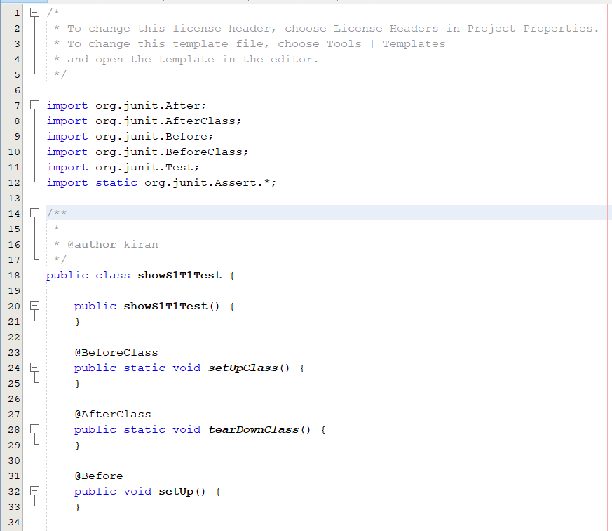
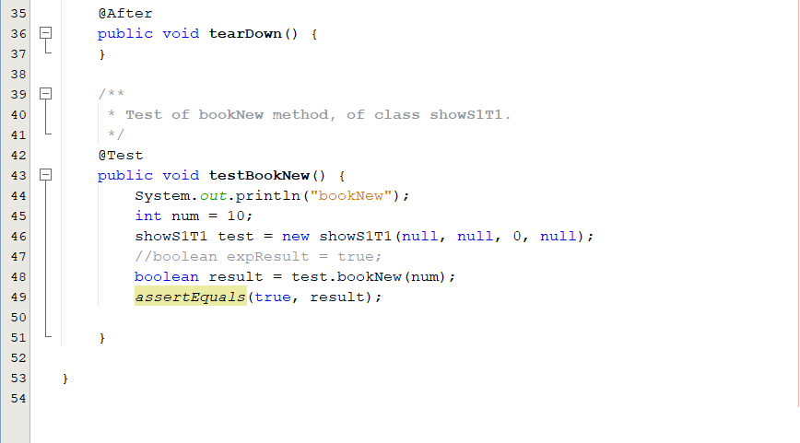

Positive case : (Input is in range i.e., 1 to 100)
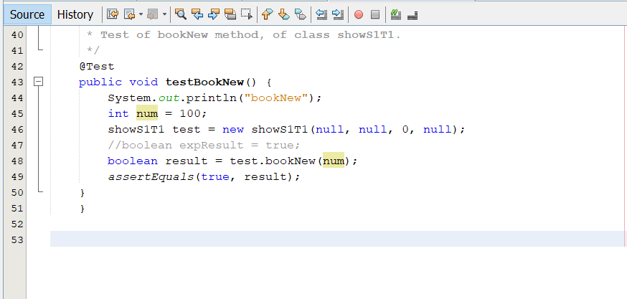

Result:
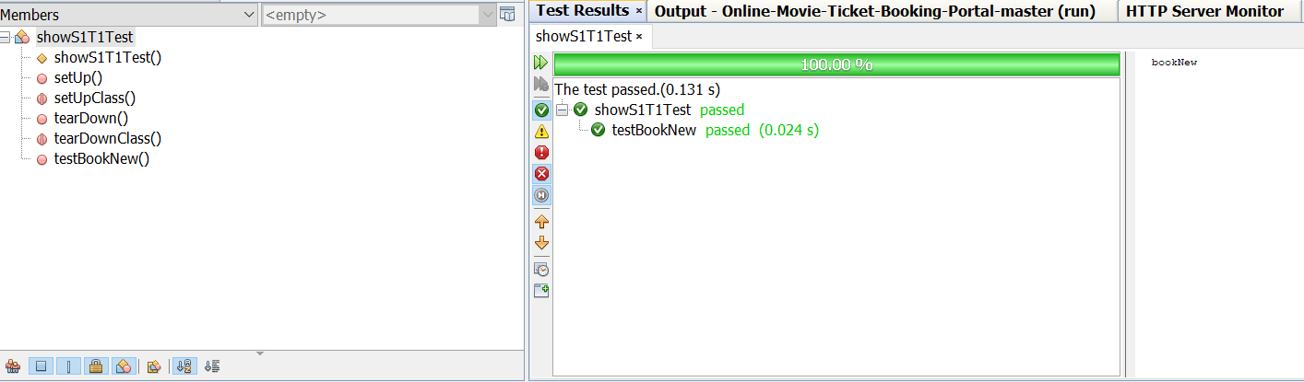

Negative case : (Input is a negative integer)
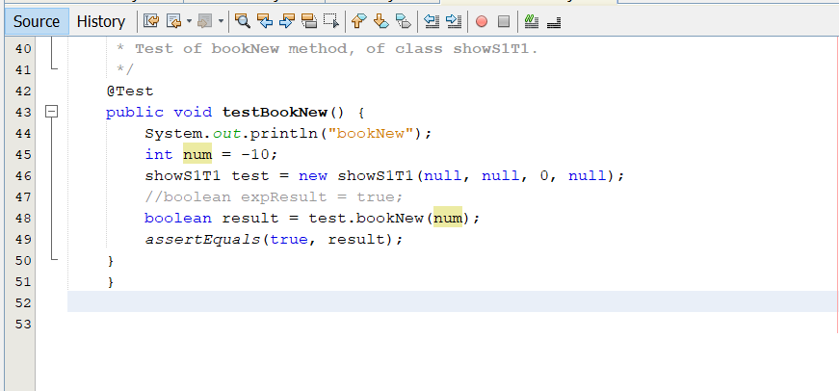
Result:
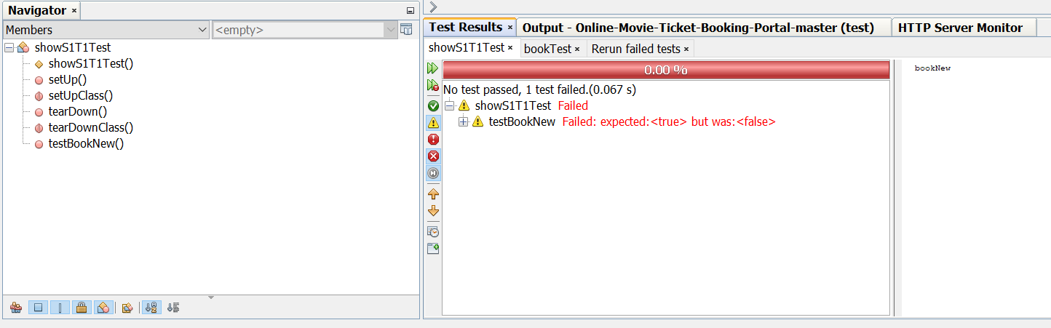

Out of Bounds case: (Input is greater than 100)
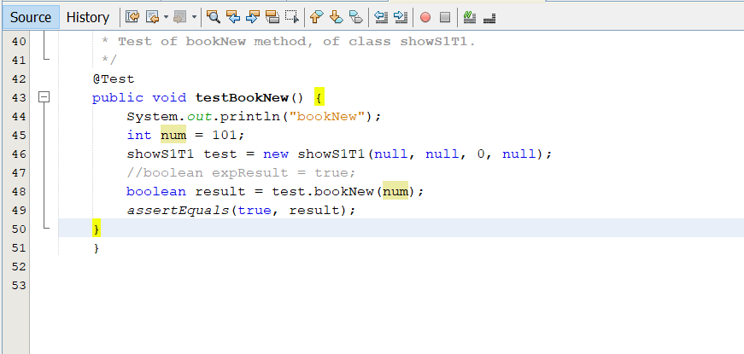
Result:
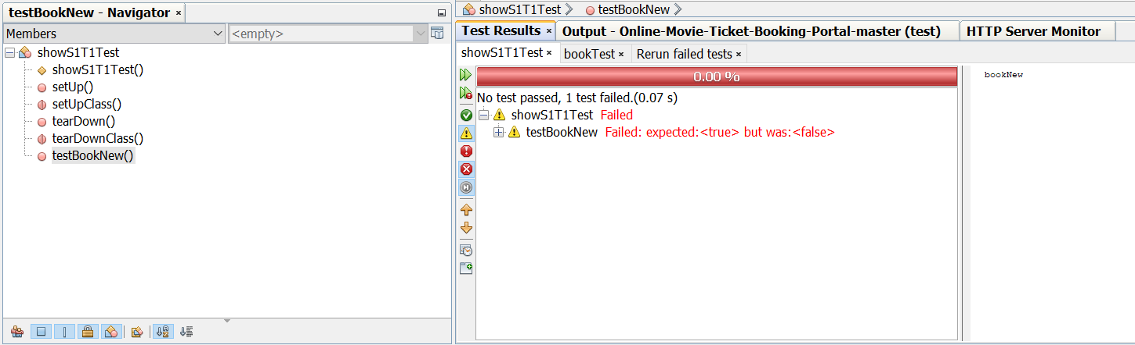

Testing Cost Calculation
Description: This case tests if the program is calculating the cost correctly based on the user selected class value (i.e., silver or gold or platinum).
Input: String with class value (silver or gold or platinum)
Output: cost of the ticket in integer form
Unit Test Code:

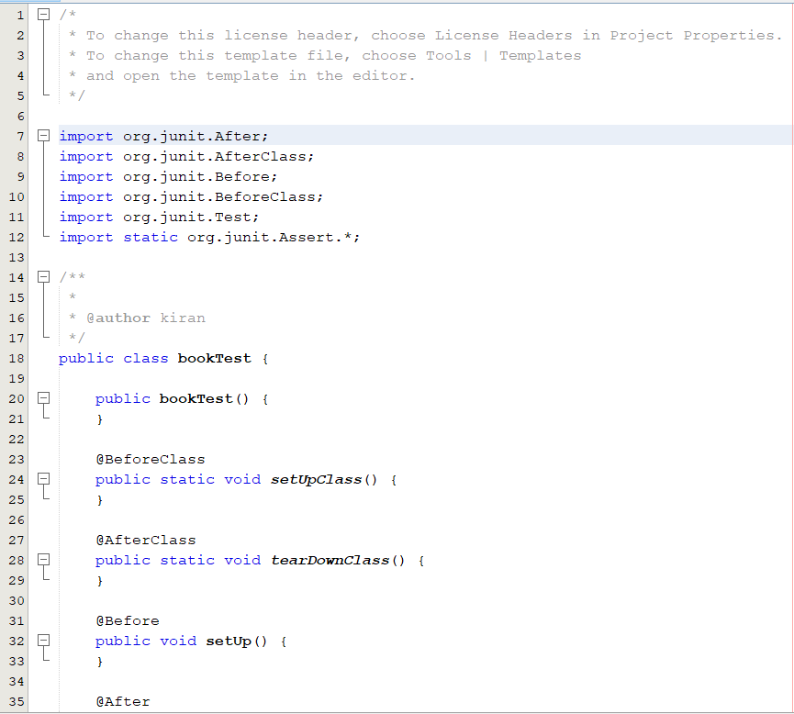
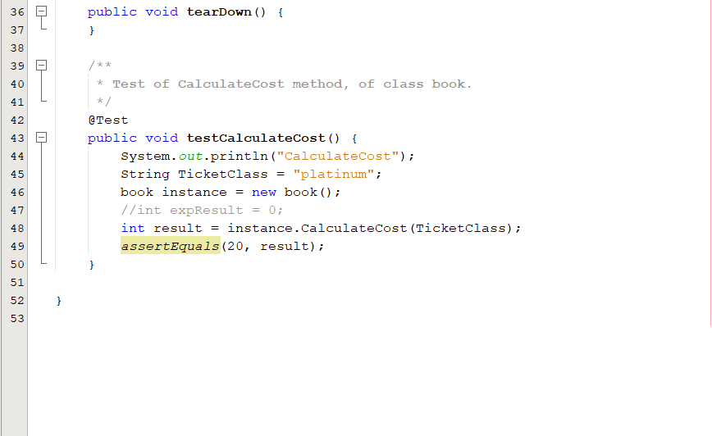

Positive case: (Input is either silver or gold or platinum)
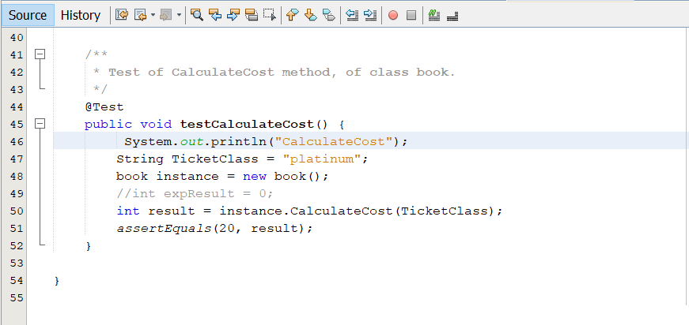

Result:
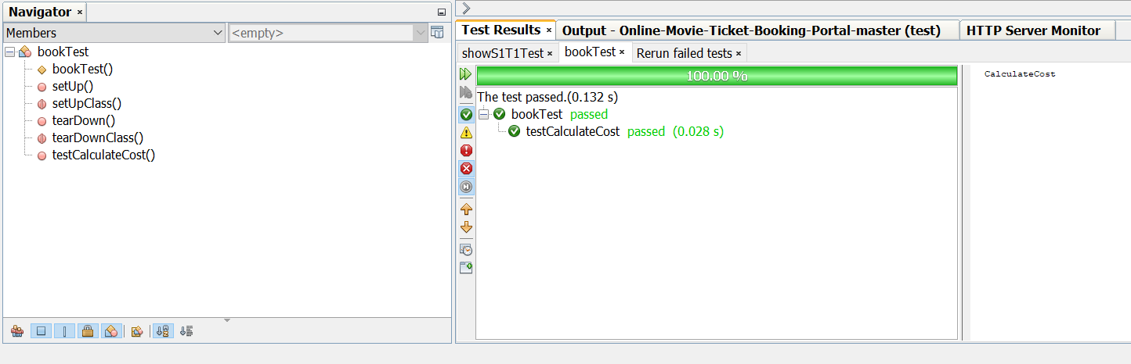

Out of Bounds case: (input is any string other than silver or gold or platinum)
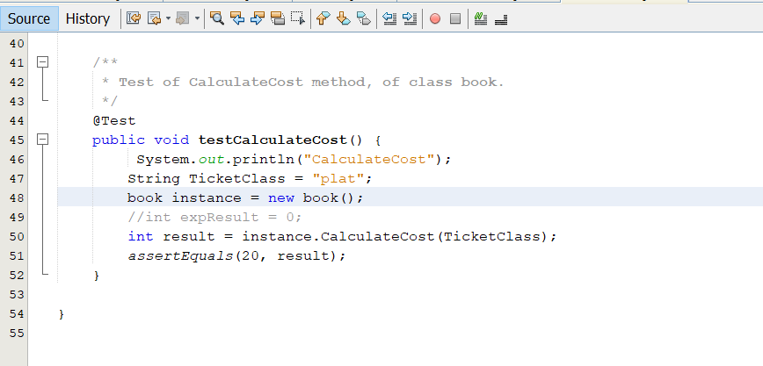
Result:
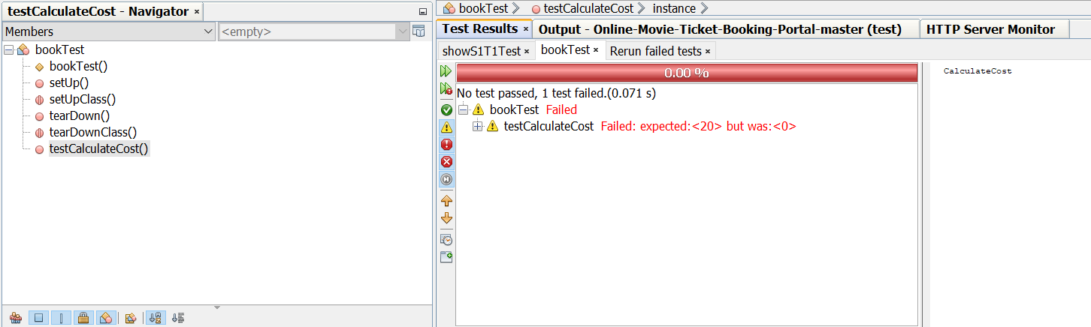

BREAKDOWN OF TEAM ROLES AND RESPONSIBILITIES
- Lohith Kumar Velkuri: Backend Java code
- Vynatheya Reddy Vuppunutula: Password encryption and documentation
- Srikanth Reddy Ettem: User interface, JSP pages and styling
- Kiran Kumar Raju Ganga Raju: Unit tests and database

USER MANUAL
In order to user our program, initially, the end-user needs to install a few softwares on their local computer.
Firstly, our application is developed using Java, which is an object-oriented programming language. We used the latest version of Java, which is Java 1.8, or Java 8. The end-user has to download the software. This can be done using the following URL:
https://www.oracle.com/technetwork/java/javase/downloads/jre8-downloads-2133155.html
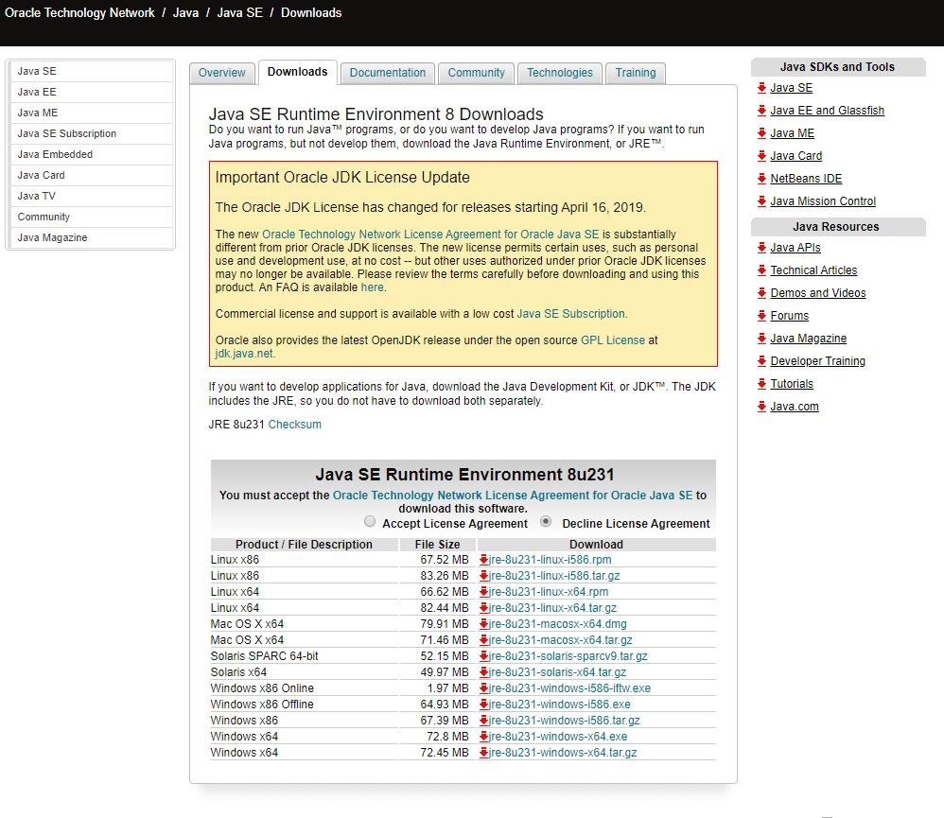

Depending upon your operating system and the bit size (32 bit or 64 bit), you need to select and download the software.
Once you install the software, you need to set class path in your computer. You need to go to Control Panel->Environment Variables->Class Path
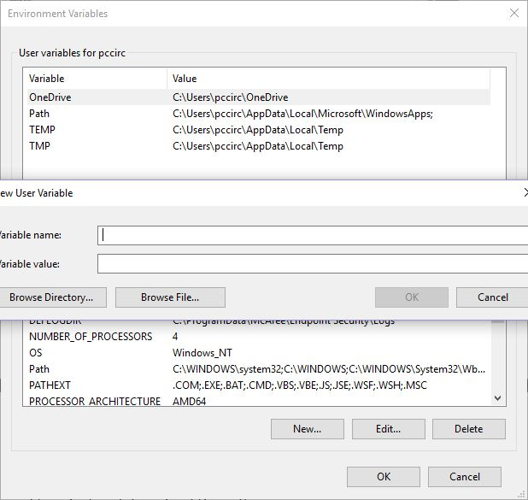

You need to enter the JDK and JRE class paths over here. Next, you need to open command prompt and type Java and Javac to check whether the installation was done properly or not.
Secondly, we need a database for every enterprise application to store repository of data. We have been suing MYSQL Server 5.5 database for our application. We can download that using the following URL:

https://dev.mysql.com/downloads/mysql/5.5.html
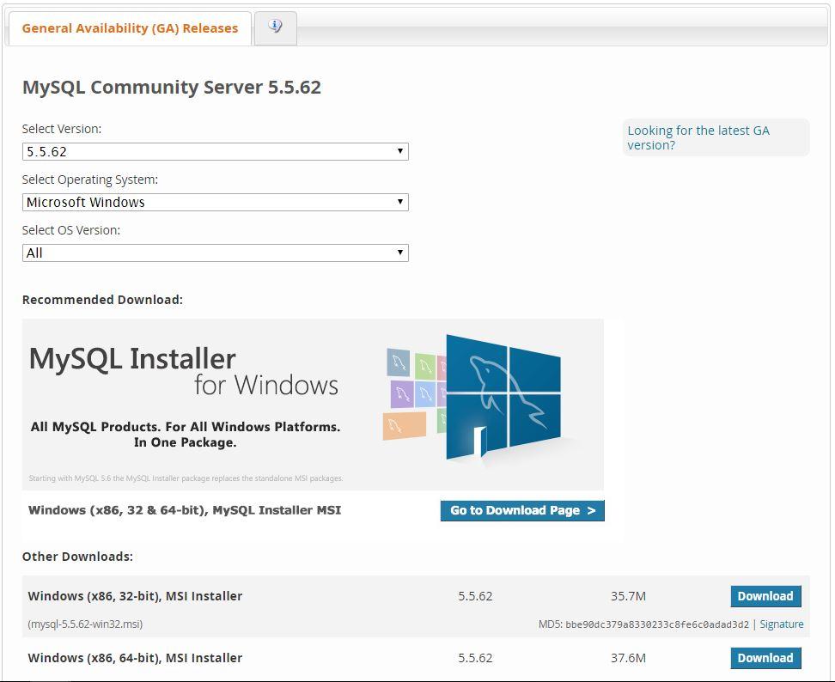

Once you are done with the installation, you need to open movieportal.sql file. This file contains the database commands, etc.
We had created Database UserDB.
We had created table structure for Users using CREATE command.
CREATE TABLE TABLENAME (Variable1 Type1, Variable2 type2, );
We had also created tables for Shows and movie database using the same CREATE command.
Next, we had dumped data into these tables by inserting data into it using INSERT command,
INSERT INTO table name (column1, column2, column3,)
VALUES (value1, value2, value3,);

Once we are done with the installation of Java and MYSQL server, we need to install an IDE.
We are using Net beans IDE in order to execute our open project. We can install it by using the URL:
https://netbeans.org/downloads/8.2/
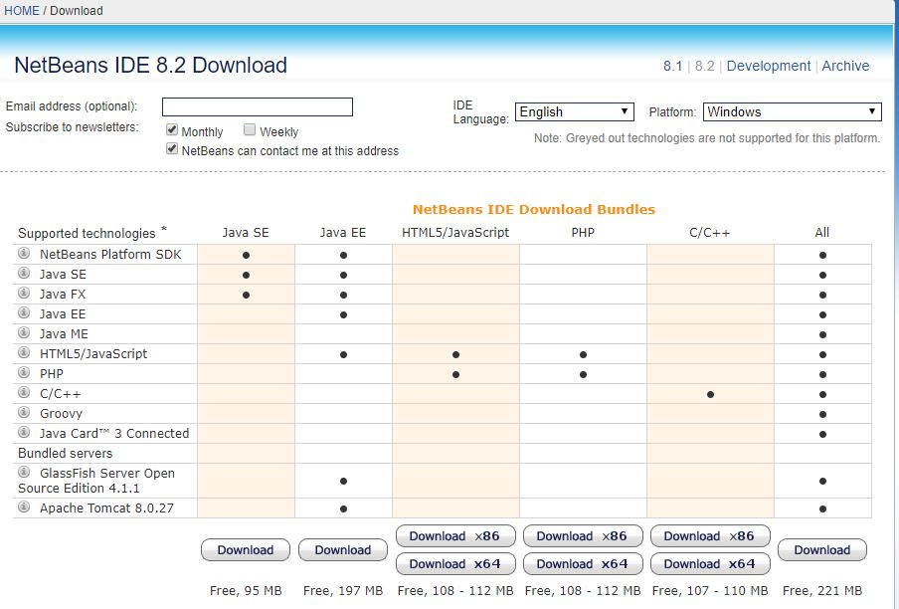

Net Beans IDE helps you execute your web application easily since it has in-built servers, provides clear overview of enterprise applications and it provides different perceptions of our data.
Along with these softwares, we have been using JDBC (Java database connectivity) in order to maintain communication between the database and the server. We have been using JDBC type 4 driver for establishing the connection.
Once you have downloaded all the softwares and while executing the application on your local machine, if the end user encounters any error, then he/she needs to delete the current JDBC driver and needs to install it again.
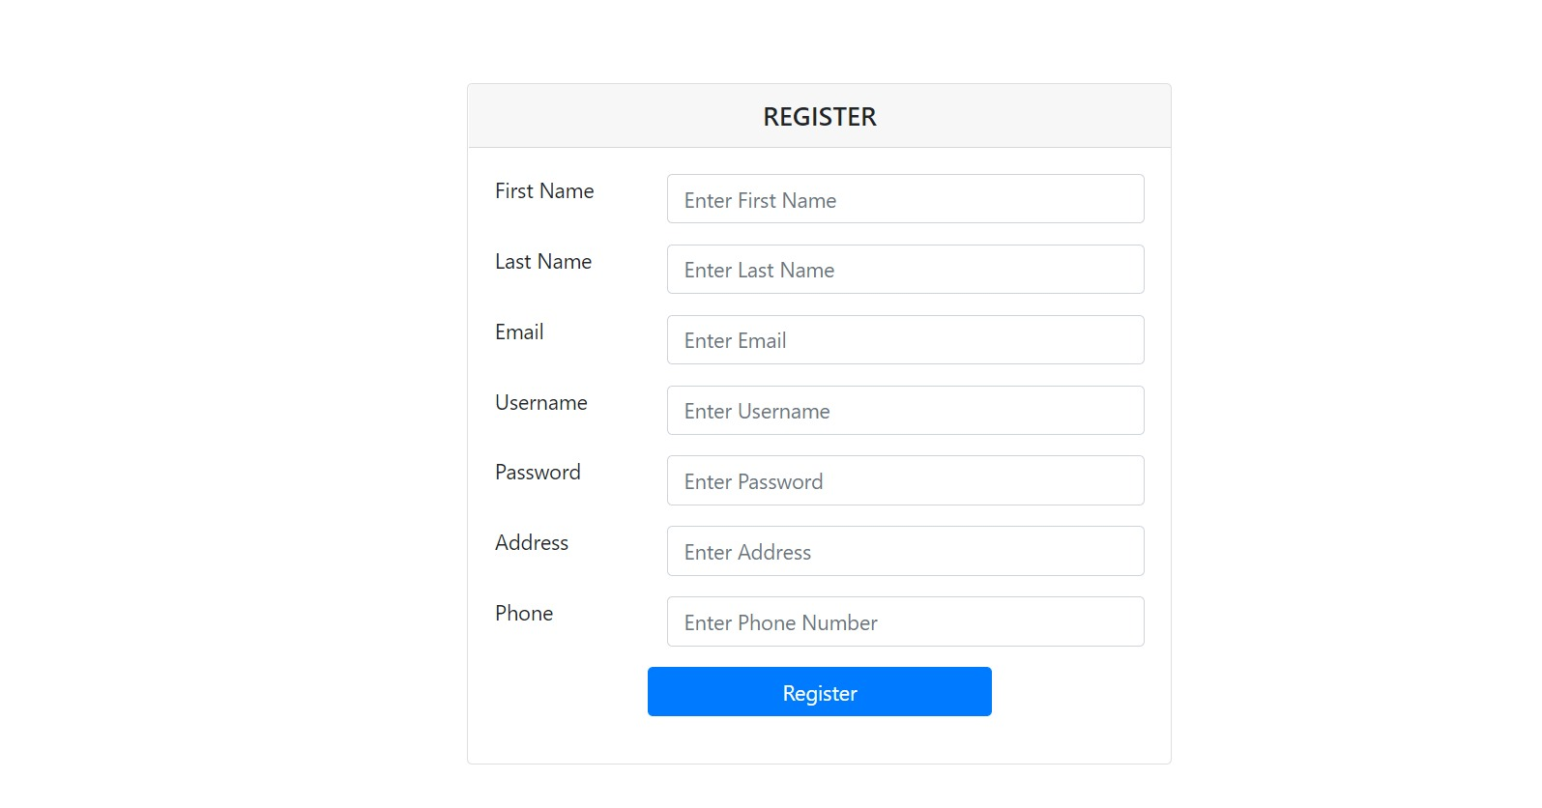
The above picture shows the registration page. New users to the web application would need to create their account by providing their details such as first name, last name, email, username, password, address and phone number. The system checks for unique username and email.
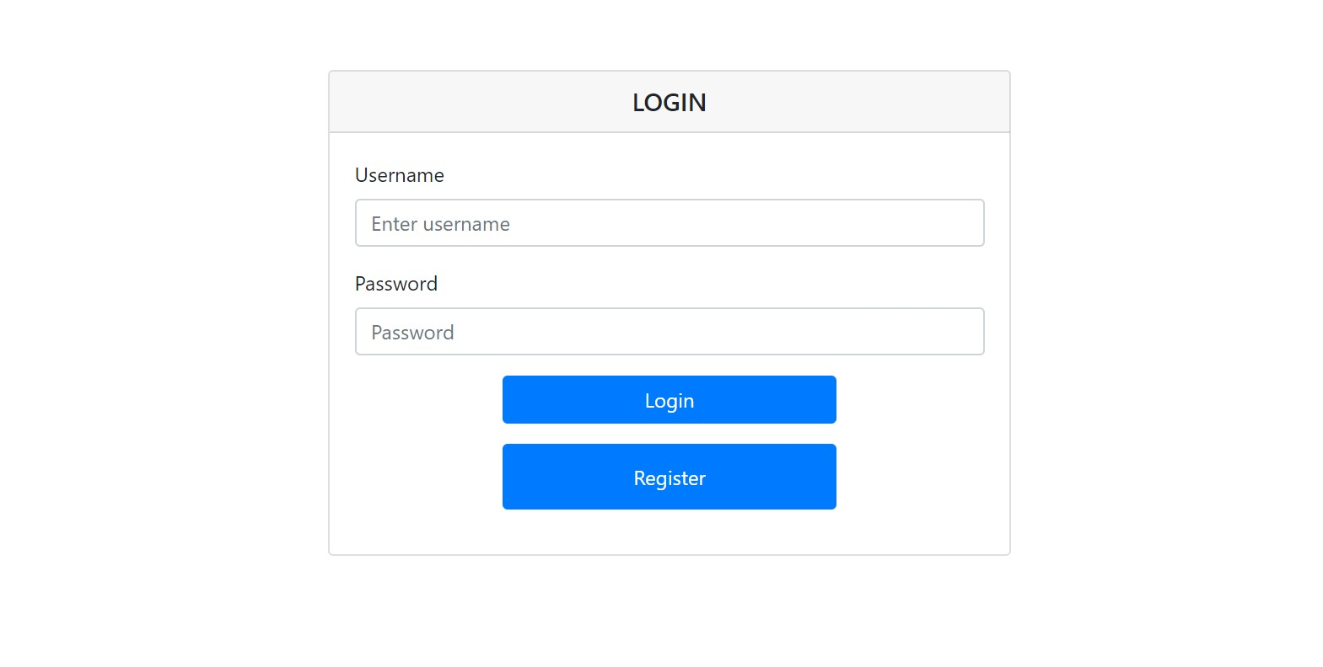
After registration is complete, the user needs to login to his/her account. For this, the user needs to enter their username and password. Upon successful login by entering the correct credentials, the user would be directed to the homepage of our web application.
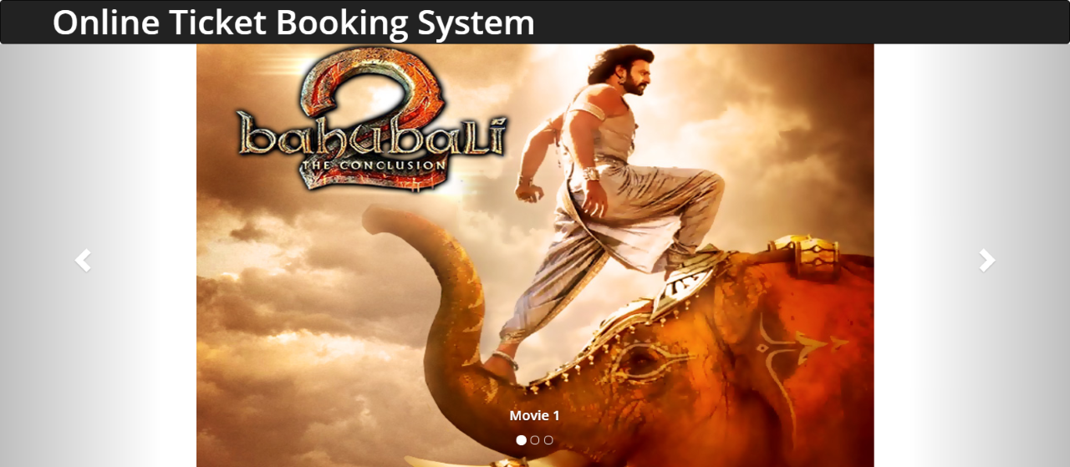

The homepage for our web application mainly deals with booking movie tickets. As soon as the customer opens the web application, he/she will be able to view the list of movies that are available to book the tickets.
First, the customer has to select a particular movie from the pool. He/she will be able to view the details about the movie like show timings, duration, screen number, number of tickets available.
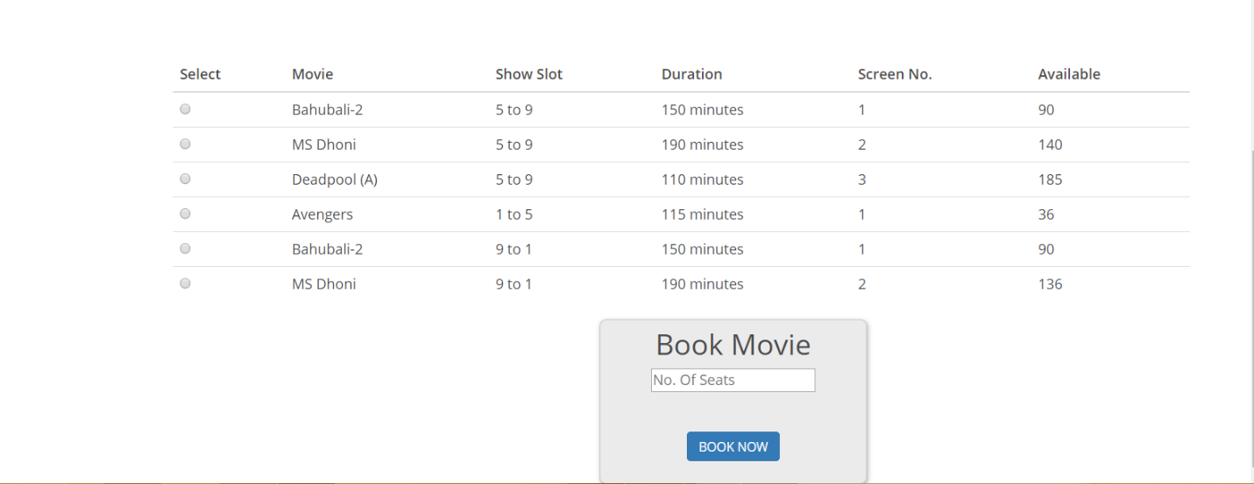

Once the customer had decided to select a movie, he/she has to select the number of tickets. Usually the number of tickets ranges from zero to number of tickets available at that moment.
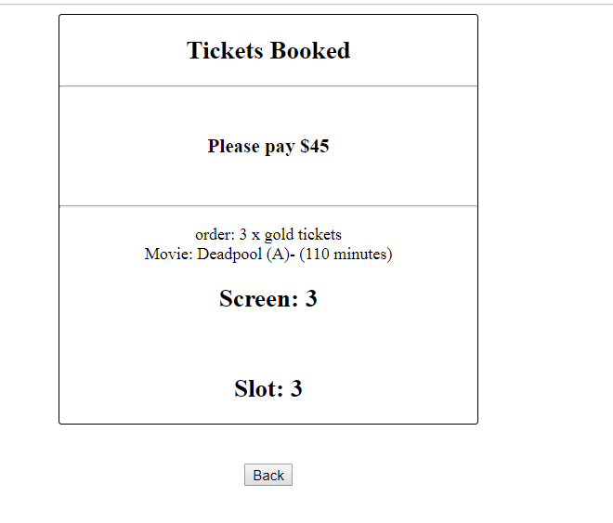
The tickets are classified into three categories:
Silver: $10
Gold: $15
Platinum: $20
Once you are done with selecting the number of tickets, you need to click on Book Now button.
You will be redirected to the next page .Here, you will be able to view the summary of the ticket and the amount required to be paid.
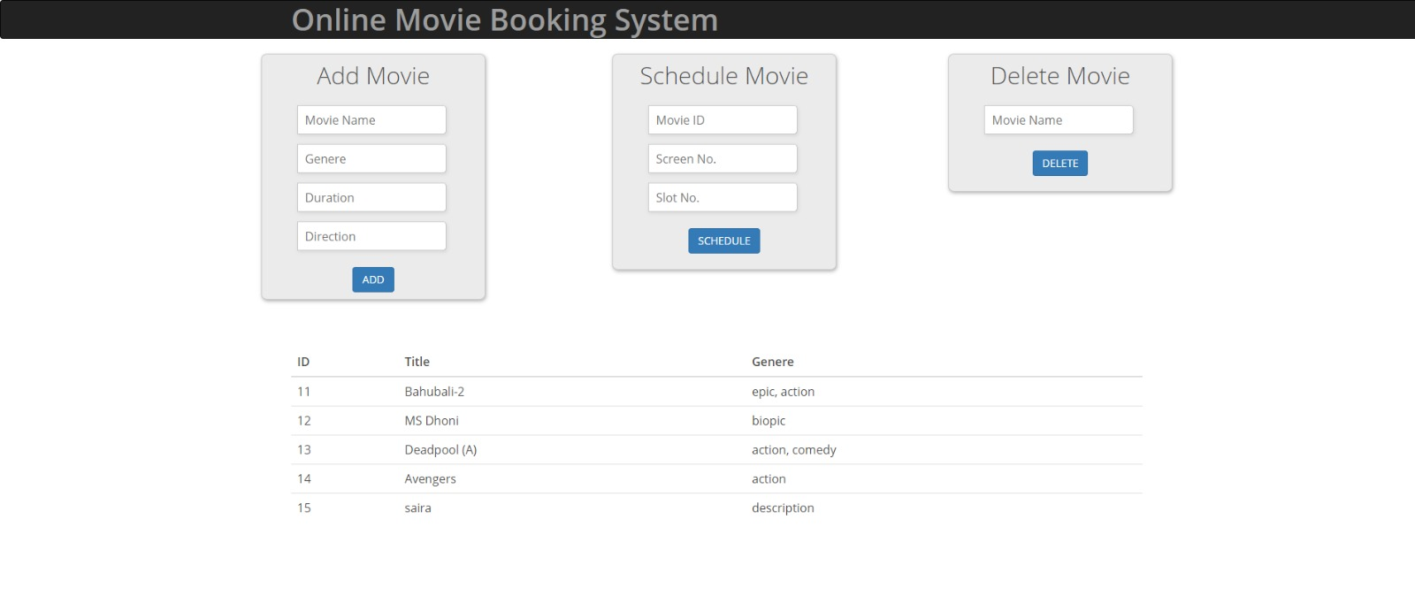
The above figure shows the admin page. The admin has three functionalities: add events, update/schedule events and delete events.

COMPILING/RUNNING THE PROGRAM AND TEST CASES
Running the test cases:
To run the test cases,
1. Right click on the test file
2. Click on run test. This will run the existing test cases automatically with the values provided manually in each test case.

Executing the code:
1. Open the project in Netbeans (We opted this as it has In-built server)
2. Right click on main project file
3. Click on clean and build
4. Now once the build is succeeded, click on run
5. This will start the server and will try to open it in the default browser set in the Netbeans
6. If the browser does not open, copy the URL from the run section and try to load the page.
7. If facing any errors related to JDBC driver connection, we need to remove the JDBC driver from Libraries folder in Netbeans and try to add the driver again. Now, without running the project again, reload the browser.

PEER REVIEW FEEDBACK
It was brought to our attention from our peers during the code inspection session that there were not enough comments and summary for the code. In this deliverable, we have fixed those issues and made our code more understandable.

CHANGES TO REQUIREMENTS AND DEVELOPMENT PHASES
Some requirements have been modified. Also, some of the components that were originally planned for Phase 2 were implemented in Phase 1 and some of the components originally planned for Phase 1 are now being implemented in the next phases. They are:
- Event information page and browse events page have been integrated into one single page, which is the homepage. This was implemented in Phase 1.
- Login and Registration pages are being implemented in this phase. We decided that since these are relatively simple components to implement, this could be postponed for further phases (after Phase 1). Instead, we decided to focus on other functionalities with high priority that are the heart of the project for Phase 1.
- Event selection page and ticket selection page were implemented in Phase 1 itself as these are critical parts of the project.

